**SmartERP**

**Proof of Concept**

SmartERP HR and employee can track actions and documents for candidates, prospective employees and current employees from hire action to departure of employee.

Value to IT

Save money

Reduce time to authenticate and record documentation to candidate

**Questions:**

What cloud environments are used?

What systems are need to be integrated?

What front ends are used?

What types of information will need to be recorded?

**Problem Statement:**

To establish a secure, trustworthy, and connected system that provides insight and information storage from hire to fire for employees

**Questions about problem statement:**

* What are the bottlenecks in the current system?
* What systems are in place and what is the current process?
* What pain points are the most important to solve currently?

**Needs:**

* To connect all internal systems, both legacy and current
  + **Questions:**
  + What kind of legacy systems are you currently employing?
  + Which legacy systems are currently effective?
  + Where are your current bottlenecks?
* Manage rapidly changing consumer demand
  + - **Questions:**
  + What are your distribution channels?
  + Manage a transparent partner network
    - **Questions:**
  + Who are your partners?
  + What is this interaction like?
  + What are the pain points within this network?

**Persona: Ivan Techanco - Director of IT**

**Key Responsibilities**

* Responsible for managing computer resources so that a company's IT systems are well-maintained and carefully protected.
* Coordinating IT activities to ensure data availability and network services with as little downtime as necessary
* Overseeing departmental finances, including budgeting and forecasting
* Identifying security vulnerabilities and eliminating them with strategic solutions that increase data security
* Directing and supporting the implementation of new software and hardware
* Coordinate and implement the systems and services that keep essential information and technology solutions available to the rest of the organization.

**Key Goals**

* Ensure efficient and effective performance of core business functions and enterprise services.
* Reduce Costs, Increase Profits
* Minimize technical expenses
* Identify the need for upgrades, configurations or new systems
* Ensure security of the systems

**Main Challenges & Pain Points**

* Too many management consoles
* Issues of security, performance and compatibility
* Lack of Budget
* Data Loss/Theft
* Inefficient security of systems
* Organizational Politics
* Lack of attention to information security

**Success Metrics**

* Propose and manage the budget ensuring the most efficient utilization of company resources to achieve its top priorities.
* Increase revenue
* Data Loss/Theft reduction

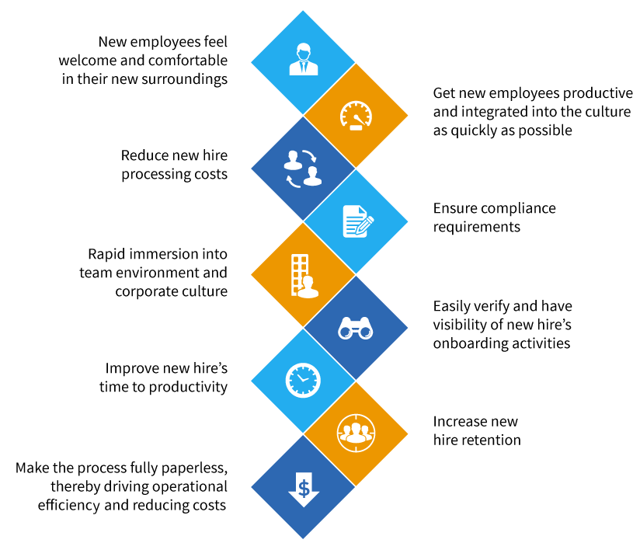

**Industry Research (General Info to Find)**

* **What are the main business components in this solution? What different roles do they play?**
* **What are the key events that take place during the hire to fire process?**
* **What kind of partners do companies in this industry use, and how does that work?**
* **What are the different types of distribution channels are there, and how do they impact the industry?**
* **What kinds of data insight is valuable to this industry?**
* **What are the main industry challenges currently?**
* **What key business personas are involved with this industry, and what are their different responsibilities and focuses?**

**Proposition:**

* Products and Services
  + ERP
  + SCM
  + Blockchain
  + IoT
  + Autonomous Analytics
* Pain Relievers
  + Integrated blockchain
  + Integrated IoT
* Gain Creators
  + Integrated blockchain
  + Integrated IoT
  + Integrated AI and Autonomous Analytics
  + Tracking exposure and analytics

**Vision Hypotheses:**

**Blockchain**

Our blockchain solution helps who want to track the hires from end to end, by reducing paperwork and increasing transparency and security, unlike traditional manual tracking.

**Internet of Things**

Our internet of things solution helps CPG businesses who want to monitor the product’s end-to-end process by reducing human error and increasing visibility.

**SCM**

Our SCM solution helps CPG businesses who want to manage the end-to-end production both upstream and downstream, by reducing cost and increasing analytic insight.

**Storyboard**

**Concept:**

* Business user needs insight into hire chain and see prospective employee, and needs to respond to changes and applications quickly as well as able to do analysis on hire process.

1. **Premise/Introduce Characters**

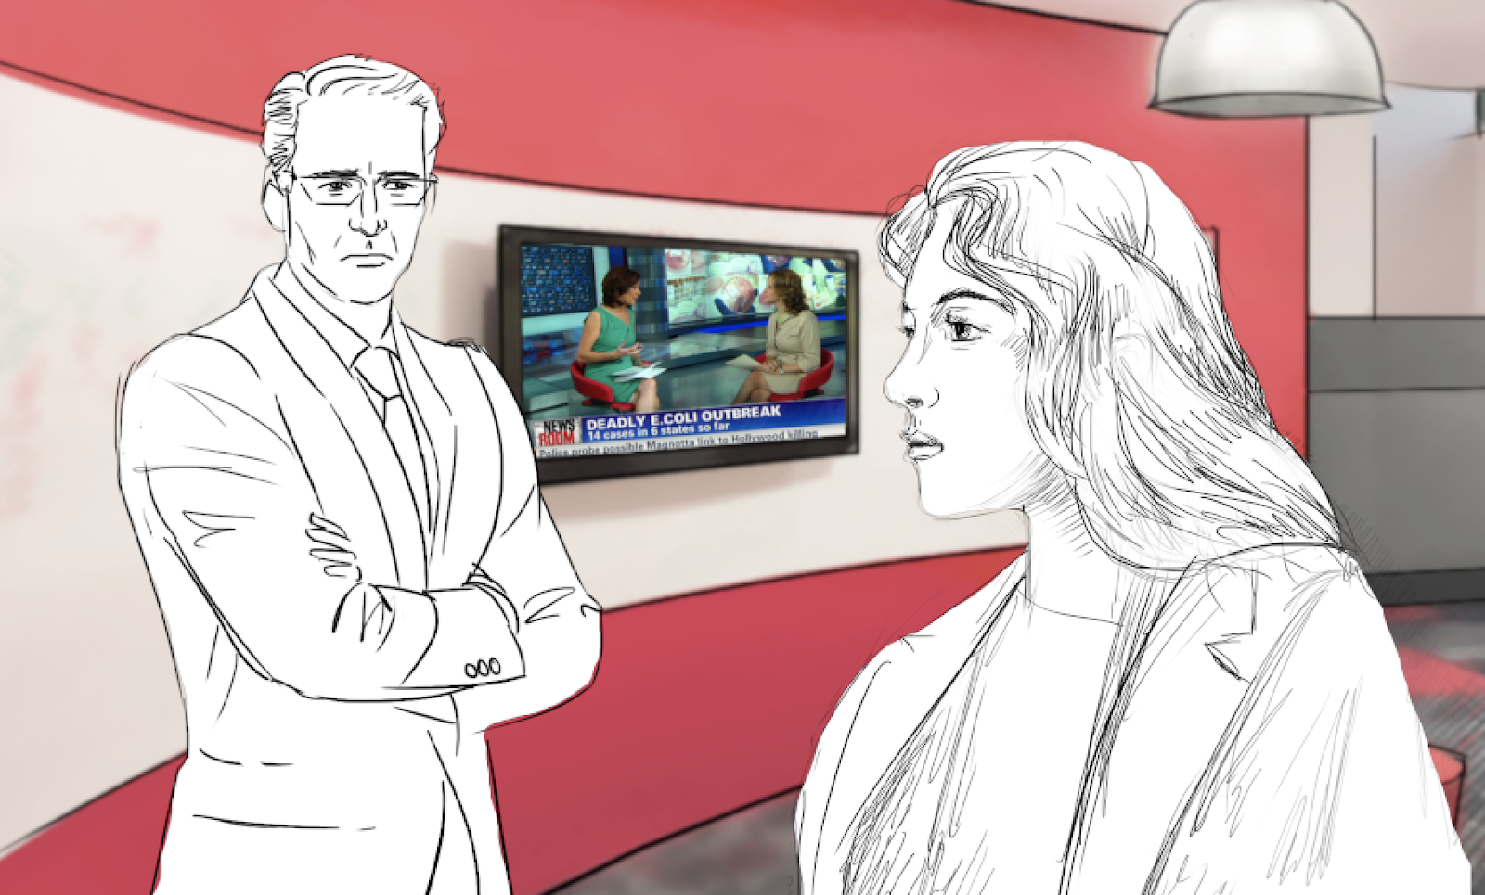

Hannah is the Head HR working at a large company.  After finding out that a lot of candidates waited along time to get hired as well some paperwork falling through, Susie has been under pressure from John, the CFO, who is looking to reduce profit loss with improved business processes.

1. **Introduce Problem**

In her discussions with John, Hannah expresses concern that their company’s end-to-end tracking process for their product may be vulnerable due to human error or lack of detail.  They are currently using a manual data entry system, and it took the team 7 days to locate the source of the issues.

1. **Character takes action to avoid problem in future**

Feeling a little overwhelmed, Hannah reaches out to a consultant in hopes of finding a modernized solution to her issues with hire chain.  Robert, the consultant, explains that there is plenty of room for improvement in their system, and that with an end-to-end integrated solution.

1. **Character learns about potential solution**

Robert explains that the integration of the Internet of Things (IoT) and Blockchain technology can provide Hannah with the data insight and robust functionality she is looking for.  He tells her how the IoT solution will provide high data granularity with real-time tracking throughout the production process, while Blockchain technology will bring transparency and security to their supply chain records.

1. **Character approves of and implements solution**

Susie is glad to hear that this solution sounds like it will fit her needs nicely.  She also discusses with Robert how this new system would allow her company to respond quickly and effectively to a recall scenario like what they just went through.  She decides to move forward with the solution.

1. **Character benefits from solution**

After implementing this solution, Hannah is thrilled with the results.  Susie’s team can now monitor the entire actions and distribution process in real-time and prevent potential problems since the implementation.  She is also happy to find that this system has improved her ability to maintain regulatory compliance and detect counterfeiting.

1. **Character is happy, looks back positively on change**

Looking back on the process, Hannah is proud of her ability to adapt to new business practices.  The business is running more smoothly than it has in years, and John even praised her ability to reduce cost by finding a solution that integrates with their other internal systems.

**Storyboard**

1.Unhappy due to hire tiem

2. Picture of profit losses on computer due to manual processes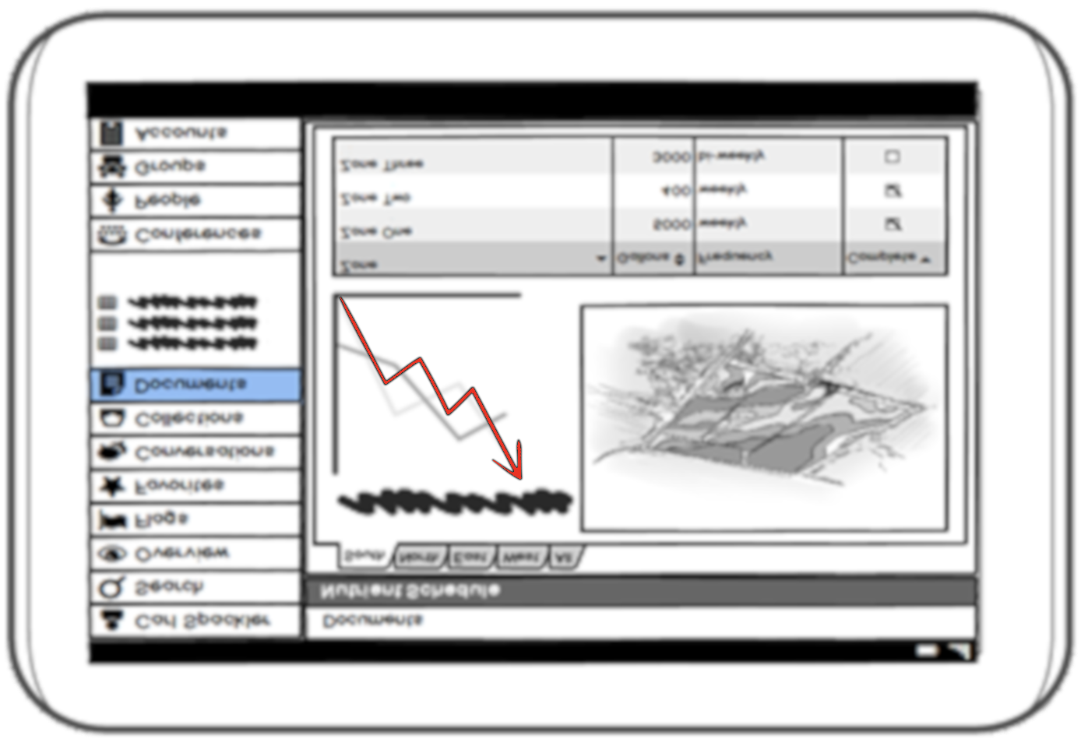

3. Intro to problem - Board room picture explaining problem of faulty processes



4. People checking the applications online



5. Hannah meeting with a consultant



6. New processes and technologies being implemented



7.Robert explains iot and blockchain

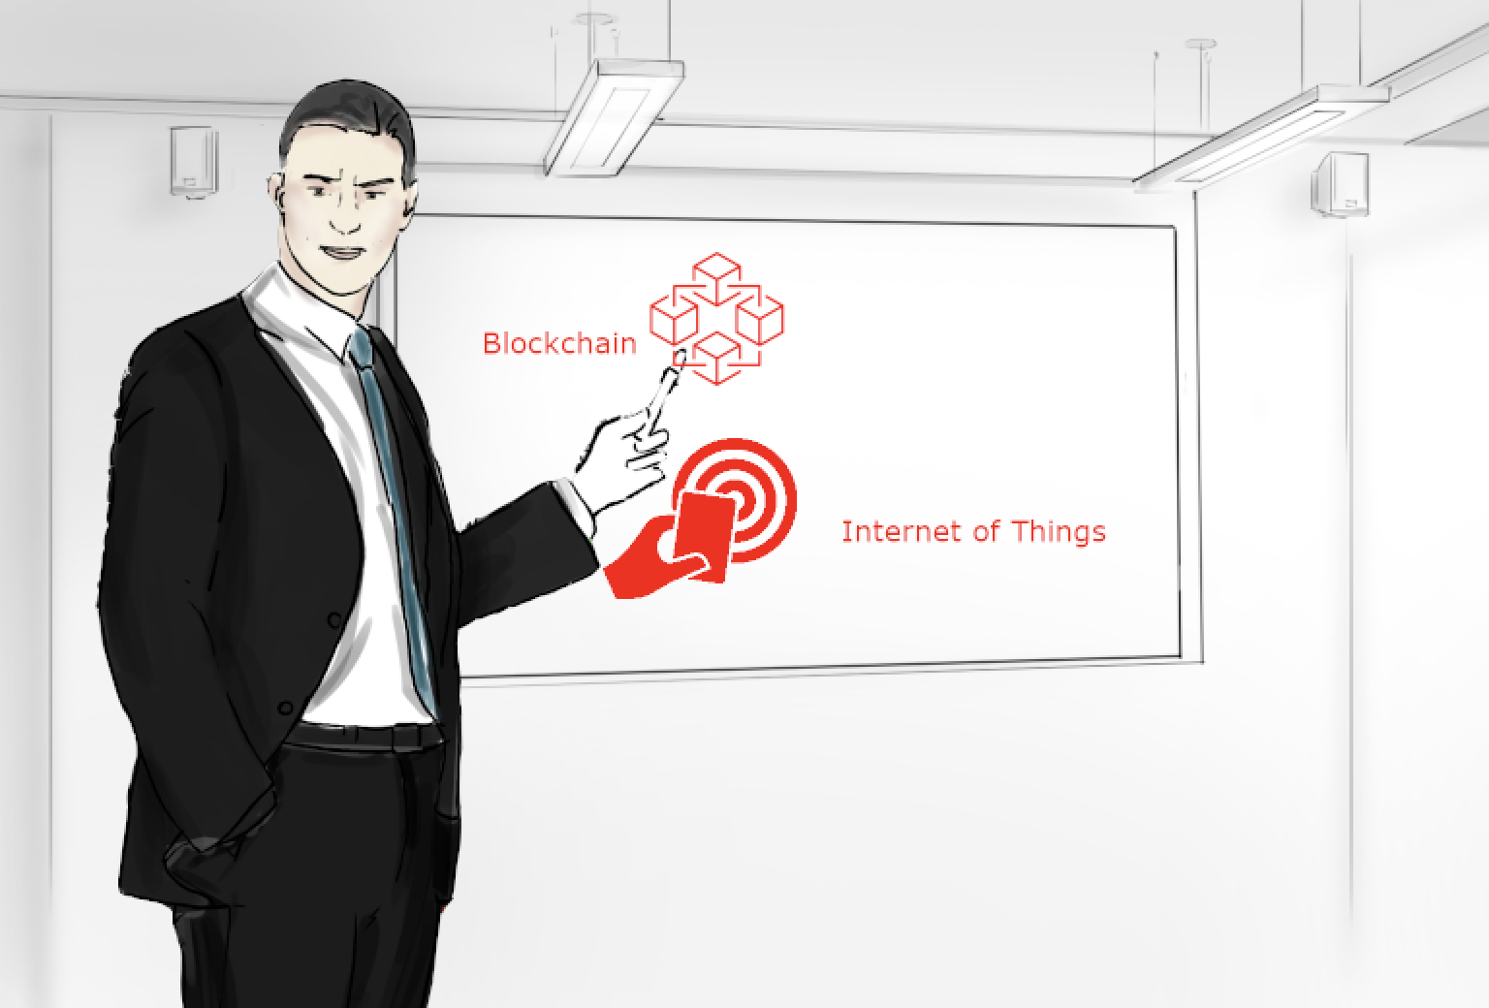

8. Showing new insights and data, maybe some sort of warning on computer

9.Hannah agrees to implement

10. Hannah can see the process and distribution in real time and sees issues in real time



11. Susie sees improved process, profits and business is running more smoothly than ever

